**Title:**

Chlorophyll Bloom Dynamics and Associations with Mesoscale and Submesoscale Features in the North Pacific Subtropical Gyre

**Running Head:**

Chlorophyll Bloom Dynamics in the NPSG

**Authors and affiliations:**

James Asha.b*, xxxa.b, and Angelicque E. Whitea.b

a Department of Oceanography, University of Hawai’i at Manoa, Honolulu, Hawai’i, USA

b Daniel K. Inouye Center for Microbial Oceanography: Research and Education, University of Hawai‘i at Mānoa, Honolulu, Hawai‘i, USA

*corresponding author ([jamesash@hawaii.edu](mailto:jamesash@hawaii.edu))

**Author Contributions:**

AEW and JA conceived of the work; JA wrote the initial draft; JA and AEW refined the initial manuscript; all authors edited the final manuscript.

**Grant sponsor information:**

This work was primarily supported by National Science Foundation (# NSF OCE 1756517 to AEW) and the Simons Foundation (#329104 to AEW).

# Introduction:

Some of the earliest ecological studies in the oceans have focused on mechanisms that drive rapid growth and accumulation of bulk phytoplankton biomass and/or distinct phylogenetic groups: e.g. the spring bloom of diatoms in the North Atlantic (1), aperiodic blooms of the diazotroph *Trichodesmium* that can lead to visually striking surface slicks (2, 3), and harmful algal blooms that can bioaccumulate in marine food webs and impact human health (4). These phenomena have since been areas of intense study, as shifts in phytoplankton biomass can alter microbial interactions, trophic structure, elemental fluxes from the epipelagic to the mesopelagic, and other aspects of ocean ecology. The spatial and temporal scales of phytoplankton blooms can vary from days to weeks and from narrow windrows of biomass to km2 scale patches (5, 6). The definition of a bloom however is not particularly straightforward and is certainly not universal; as described by Smayda (7): “what constitutes a bloom…has regional, seasonal, and species-specific aspects; it is not simply a biomass issue.” This is clear when considering the relatively low variation of phytoplankton biomass estimates even within the oligotrophic subtropical gyres that occupy ~40% of the global surface area (8). In the North Pacific Subtropical Gyre (NPSG, Figure 1), the seasonal mean range in chlorophyll (CHL, a proxy for phytoplankton) in the near surface waters is only ~0.15 mg m-3 (9, 10) as measured by the Hawaii Ocean Time-series (HOT) at Station ALOHA (22.75°N, 158°W). Much of this seasonality is driven by photoacclimation, whereas phytoplankton modify their cellular pigment concentrations in response to the seasonal cycle of insolation (11, 12). This relatively low seasonality in surface phytoplankton biomass led to earlier conceptualization of the NPSG and other subtropical gyres as ‘ocean deserts’ (13) typified by ‘endless summer’ (14).



The HOT program has sampled the NPSG at Station ALOHA at near monthly intervals since 1988, and found that blooms (enhanced CHL or specific classes of organisms) are generally confined to summer months and often associated with N2 fixing organisms (diazotrophs). In 1996, a transect from Station ALOHA to Station CLIMAX (28°N) utilizing a towed underway system sampling at 45m, observed a large bloom spanning ~250 m with peak CHL concentrations of ~0.4 mg m-3. Net tows along this transect revealed high concentrations of the diazotroph *Trichodesmium* and pigment analyses indicated high levels of the diatom pigment fucoxanthin, perhaps pointing to diatom-diazotroph assemblages, DDAs (15). This finding is not atypical as blooms of *Trichodesmium* are frequently reported at or near Station ALOHA (16-19). Later in the record, Fong et al. (20) observed surface CHL ranging from 0.2-0.4 mg m-3 within an anticyclonic eddy near Station ALOHA. Sampling of this feature revealed a high concentration of an assortment of N2-fixing organisms. In addition to observations of elevated concentrations of diazotrophs in summer at Station ALOHA, there are also documented pulses of particle export to the deep sea in the summer months that have been attributed to shifts in the microbial community to diatom-diazotroph assemblages (21). Overlying the seasonality of export productivity at this location are long term trends; Karl et al. (10) report a 30-yr long increase in CHL, suspended particulate carbon and nitrogen, and primary production at Station ALOHA. The proposed drivers of these oligotrophic summer blooms (and associated particle flux) include (1) enhanced iron flux, (2) physical aggregation of buoyant cells (such as *Trichodesmium*), and (3) nutrient intrusions into the euphotic zone via mesoscale eddy pumping (15, 21). These late summer CHL blooms do not seem to be correlated with sea surface height anomalies or wind forcing but this has not been rigorously tested (9, 22).



To the north of Station ALOHA, large summer blooms of satellite-derived chlorophyll (CHLsat) spanning hundreds of square kilometers and persisting for weeks to months, are consistently observed in satellite records at an approximate latitude of ~30°N (23) in the NE region of the NPSG (here termed NEPSG). These blooms are operationally defined as having a CHLsat value greater than 0.15 mg m-3, which is ~3× greater than the literature background CHLsat level of 0.05 mg m-3 for the oligotrophic oceans (23-25). These blooms occur at a near annual rate, and uniquely within the late summer months of June-October (23, 26-28). Remote sensing of ocean color was first used to describe these CHLsat blooms occurring in the oligotrophic in 2003 through the use of the Sea-viewing Wide Field-of-view Sensor (SeaWiFS) ocean color satellite (28, 29). In 2002, Wilson et al. serendipitously sampled a CHLsat bloom in the NEPSG region and observed an elevated abundance of the diazotrophs, *Trichodesmium* and *Rhizosolenia* (a diatom that can harbor *Richelia*) (28). Later studies have attempted to characterize the biological and physical components of the NEPSG blooms (23-26, 30), but to date no one system of biophysical drivers has been conclusively established. Currently, there are six not necessarily independent hypotheses as to what causes the inter-annual CHLsat blooms in the NEPSG; these include (1) stimulation of di-nitrogen fixing bacteria via iron or phosphorus inputs, (2) inputs of nitrate from vertically migrating mats of the diatom *Rhizosolenia* (26, 28) (3) nitrate inputs into the euphotic zone via breaking of internal waves or subsurface mixing (26, 31), (4) the entrainment of nutrient rich deep water into the mixed layer driven by an increase in Ekman transport across a northward Sea Surface Salinity (SSS) gradient (23, 24, 28, 32) or (5) regulation of horizontal dilution rates which may impact phytoplankton growth and grazing rates (30). Lastly, (6) the NPSG is generally an area of converging surface currents which is conducive for the aggregation of buoyant phytoplankton (23), such that these ‘blooms’ may not result from local growth but rather concentration of living biomass along surface current fronts. These mechanisms are in many ways a recapitalization of the age-old debate in ocean ecology of the relative importance of bottom-up versus top-down controls on standing stocks of phytoplankton and are not easily disentangled.



From a bottom-up perspective, large mesoscale eddies and submesoscale flows in the open ocean can both induce vertical and horizontal motion, leading to oscillations of isopycnals which may influence plankton biogeochemistry through changes in the distributions of nutrients within the euphotic zone. In cyclonic eddies for examples, isopycnal layers are uplifted, inducing upwelling at the eddy's core which can enhance the supply of growth-limiting inorganic nutrients into the well-lit upper ocean. Conversely, in anti-cyclonic eddies isopycnal layers are depressed, inducing down-welling at the eddy's core and driving deepening of nutrients at the surface ocean (33-35). In the oligotrophic NPSG as well as the North Atlantic, anticyclonic eddies have been observed in conjunction with elevated N2 fixation rates and/or elevated concentrations of N2 fixing organisms (20, 36, 37) although as Böttjer et al. (37) noted at the time “the exact physical, biogeochemical, and ecological processes underlying this apparent mesoscale stimulation of diazotroph activity in the oligotrophic ocean have yet to be identified.”

How might mesoscale eddies lead to enhanced phytoplankton biomass and what is the evidence for such drivers in the NPSG? The work of Guidi et al. (38) and Wilson (39) provide some observations and hypotheses. In 2008, Guidi et al. (38) combined high-resolution biogeochemical and physical data sets collected to examine the evolution of a *Trichodesmium* bloom occurring in the frontal transition zone between a weak anti-cyclonic and cyclonic eddy near Station ALOHA. They argue that the interaction between the two eddies generated horizontal stirring, i.e. sub-mesoscale frontal regions, that controlled the distribution of phytoplankton biomass leading to elevated chlorophyll a, particle concentrations, and export flux in the frontal region where *Trichodesmium* concentrations were elevated. Specifically, the sub-mesoscale frontal effects are twofold, (1) the upward component of sub-mesoscale fronts can transport nutrients into the euphotic zone enhancing phytoplankton growth, while (2) the downward component can subduct phytoplankton below the euphotic zone into the subsurface and ultimately drive biomass export into the deep ocean. Conversely, Wilson (2021) present Biogeochemical-Argo float data near 30°N and argue that cyclonic eddies play an important role in mesoscale nitrate shoaling events (and hence injections of nitrate to the lower euphotic zone). In this study, most of these nitracline shoaling events (7 of 8) were associated with cyclonic eddies during phases of eddy shedding, merging, or during periods when eddy speed changed significantly (39). These nitrate injection events were followed by increased surface CHLsat. From a top-down perspective, once blooms have been initiated, Lehahn et al.(30) use a simple ecosystem model to show that “dispersion/dilution of fine-scale nutrient-enriched water may regulate the dynamics of nutrients–phytoplankton–zooplankton ecosystems and enhance accumulation of photosynthetic biomass in low-nutrient oceanic environments.”

While many of the past studies of bloom dynamics in the NPSG/NEPSG have focused on the potential biophysical drivers of phytoplankton blooms using a threshold approach, ( e.g. CHL> 0.15 mg m-3 is a bloom), none have explicitly addressed the fact that the seasonal photoacclimation is a strong component of the CHL signal in the subtropics (11, 12). The process of photo-acclimation, where phytoplankton modify their cellular pigment concentrations in response to the seasonal cycle of insolation, leads to lower mean CHL values in summer months with the highest irradiance and highest mean CHL in lower light winter months. Consideration of these processes, and removal of the seasonal trend, may lead to a clearer relationship between CHL anomalies (~blooms) and mesoscale eddies or frontal features. In accordance with Wilson et al. (2021), we recognize that the underlying bloom mechanisms likely differ between 30°N and Station ALOHA, and so we have attempted to construct a approach that similarly addresses drivers of biomass accumulation in both regions (39). We achieve this by defining a bloom threshold based on the seasonally (photo-acclimation) detrended CHLsat fields, and employing a method developed by Guo et al. (40) that utilizes sea level anomaly (SLA), and finite sized Laplacian exponent (FSLE) satellite data with a broad spatial coverage mapped to CHLsat.

The purpose of this study is to characterize seasonally-detrended CHLsat anomalies in the NPSG at Station ALOHA as compared to the 30°N region (see Figure 1) where canonical summer blooms have been reported (23, 28). We have characterized the magnitude, frequency, and persistence of CHLsat blooms in these regions and quantitatively examined associations of these blooms with mesoscale and sub-mesoscale features to identify potential physical drivers of CHLsat anomalies. We perform a cluster analysis using sea level anomaly (SLA) fields in conjunction with FSLE fields to determine a spatial association between anomalous CHLsat and mesoscale and submesoscale features (sub-mesoscale), following the methods outlined in Guo et al. (40) in order to determine the relative association of mesoscale and submesoscale regions with CHLsat patterns for each of the bloom region. Lastly, we present a case-study time-series of one characteristic CHLsat bloom in each sub-region, in order to better understand the time-resolved change in phytoplankton biomass and how it relates to chemical and physical drivers of biomass growth and accumulation.

# Methods:

## Datasets

Finite Sized Laplacian Exponent (FSLE) fields (4 km spatial resolution, 1 day temporal resolution) were obtained from the Archiving, Validation, and Interpretation of Satellite Oceanographic data (AVISO) web server. FSLE is defined as the inverse time of the separation of two particles from their initial distance to their final distance. Sea Level Anomaly (SLA) fields (4 km, 1 day resolution) were downloaded from the Copernicus Marine Server (CMEMS). All eddy related parameters including type, amplitude, radius, and lifetime were accessed through the CMAP webserver, originally supplied by the AVISO Eddy Ocean Atlas, and downloaded using the cmap4r package in R. Satellite chlorophyll (CHLsat) from the merged GSM CHL1 product (4 km, 1 d resolution) was downloaded using the wget web scraper from the GlobColour ftp server. The date range of concurrent available satellite data was January 01, 2002 to October 15th 2019. The daily FSLE, CHLsat, and SLA products were re-sampled to 4 day resolution, and the CHLsat and SLA data were subsequently re-sized to the FSLE grid using a bi-linear method, i.e. each output grid cell is a linear interpolation of the nearest 2×2 grid cells from the original CHL and SLA matrices, respectively.

Here we use the term mesoscale to describe any physical feature that occurs on the order of one month in time, and within 10 km2 to 200 km2 in size. An eddy is then defined as a mesoscale feature that experiences high rates of strain and is comprised of two parts: a region of high vorticity known as the core, surrounded by a circulation cell known as the ring (41). The submesoscale describes any physical feature less than 10 km in size and is representative of current fronts associated with twisting and stretching. Submesoscale and mesoscale (meso-submesoscale) features are identified using the FSLE fields, and SLA fields (40).

In order to validate the CHLsat product, in situ HPLC CHL (high-pressure liquid chromatography) data from the upper mixed layer (25 m) were downloaded directly from the Hawaii Ocean Time-series ftp webserver; these data are at near monthly resolution. The geometric mean of a 3×3 pixel region (12 ×12 km) around Station ALOHA was subset from the CHLsat time-series and matched by time-stamp (± 1 day) to the HPLC CHL data; a linear regression between HPLC and the CHLsat product was performed (Figure 2).

## Study region

We have defined two distinct study regions: one centered at Station ALOHA and the other at 30°N, 158°W. The former is not impacted by the seasonal migration of the North Pacific transition zone; the latter is impacted by the North Pacific transition zone and exhibits strong interannual variability (23-25, 27). The bloom regions were chosen by first generating a contour map of the CHLanom in the NPSG **(**Figure 3**)** and the smallest possible box was defined for each region that completely encompassed all large scale CHLsat anomalies (CHLanom, defined in the next section) features. Defining the bloom study regions in this way is ultimately subjective and there are slight variations in box boundaries compared to previous studies (23, 24), but this choice allows us to focus on a central bloom region. Importantly, we examine relationships between CHLanom, FSLE , and SLA fields at every gridded point within each bloom region. The longitude latitude boundaries of the two study regions are [-159, -157, 22, 23] and [-163, -132, 27, 35] respectively. Furthermore, the boxes are defined only to mark general bloom regions, and are used to determine the frequency of bloom occurrences, but the subsequent statistical analysis is not heavily dependent on the box boundaries (data not shown). The monthly mean climatology for a 12 × 12 km region around Station ALOHA was also calculated for both the CHLsat (Figure 1) and CHLanom products (Figure 3). Based on this climatology, we have focused on the late summer months (July-October) of each time-series where blooms are more apparent. This temporal window is consistent with the approach of Wilson et al. (27, 39, 42) which observed blooms to be roughly restricted to the June-October. To capture the peak of the late summer CHLsat blooms, only SLA, FSLE, CHLsat, and CHLanom data from July-October were used in all the succeeding statistical analysis.

## Time-series analyses and Bloom definition

To remove the seasonal and climatological signal from the CHLsat product, a seasonal trend decomposition using loess (STL) filter was applied to each grid cell of the CHLsat field. Using a local polynomial regression fitting loess technique, an STL filter decomposes a time series Yt, into three parts: the seasonal trend St, the climatological trend Ct, and the residuals Rt, such that...

$$Y_{t}=S_{t}+C_{t}+R_{t}$$

To capture CHLsat bloom occurrences within the Rt component of the time series decomposition, the STL settings of a 365-day period, a 31-day running window, and a 4-iteration outer loop were used. The seasonally filtered CHL anomaly (CHLanom) was defined as the residuals of the STL decomposition for each pixel in each bloom region,

$${CHL}_{anom}=R_{t}$$

A bloom threshold was then defined as the median plus the mean absolute deviation (MAD) for each grid cell across the length of the data set of the Rt fields. Two separate mapped raster objects of CHLanom and bloom flags, represented by 0’s (negative) and 1’s (positive), were saved to be used in future analysis of bloom persistence and spatial scale.

## Exploratory Cluster Analysis

A k-means cluster analysis was applied to the daily SLA and FSLE fields from each study region, Station ALOHA and 30°N, to group the parameters into (sub)mesoscale categories, and a percent association of positive CHLanom values is derived for each (sub)mesoscale group. We take the approach outlined by Gou et al. (40) where a k-means clustering algorithm (k = 4) is used to group the SLA and FSLE data points into one of four physical regions based on the clusters centroid location in FSLE-SLA space (Figure 4) i.e. positive mesoscale, negative mesoscale, sub-mesoscale and mixed.

To achieve this, the FSLE and SLA gridded fields are scaled from 0 to 1 then converted to a long format data frame. The inputs of the k-means analysis are the FSLE and SLA columns, and for each FSLE and SLA pair, the output is a (sub)mesoscale group factor of 1, 2, 3, or 4. The four starting centroids of the k-means cluster analysis were set using the mean and standard deviations of the SLA and FSLE fields (Figure 4). For display purposes the (sub)mesoscale groups are re-grided into latitude and longitude space. All subsequent analysis utilizes a data frame that is the concatenation of the previously described satellite fields, and has columns corresponding to date-time, longitude, latitude, SLA, FSLE, CHLanom, bloom flag, and (sub)mesoscale group factor.

To determine the association of the CHL blooms with the (sub)mesoscale regions, the percent of CHL bloom data points grouped in each (sub)mesoscale region was calculated. The percent association to (sub)mesoscale regions is given in Table 1 for all blooms that occurred during the late summer months, between the years 2002 and 2019. Blooms years with large scale chlorophyll events that occurred in the late summer months were chosen subjectively by viewing monthly CHLanom maps (Figure 1). To determine if the bloom's (sub)mesoscale signature differed from the background (sub)mesoscale signature, repeat estimates of the standard deviation were found via bootstrapping. Values that fell outside of three standard deviations away from the mean background (sub)mesoscale signature were considered to be significantly different and are denoted by an asterisk.

## Case study description (WORK IN PROGRESS)

Following the approach of Lehahn et al. (30), we have described the evolution of a bloom observed in 2018 that impacted both regions of study. We describe the accumulation of CHL biomass integrated spatially over each bloom patch surface area and compare the persistence and relative potential drivers of these blooms.

# Results and Discussion:

Validation of the CHLsat product was performed versus in situ HPLC-derived CHL from the HOT program. CHLsat well approximated the seasonal cycle at Station ALOHA, and we find a significant linear regression (r2 = 0.45, p < 0.05, n = 56) with a slope of 0.46 and intercept of 0.048 (Figure 2). This gives some measure of confidence for the regional CHLsat and derivation of bloom events.

Although the general seasonal trend of HPLC and CHLsat are similar, the greatest deviation of HPLC from CHLsat occurred in the late summer months (Figure 2), when large scale chlorophyll blooms are predominantly observed. The observation of mesoscale CHL blooms in the satellite product going unobserved in the HPLC bottle samples is consistent throughout the time series. This is possibly due to the lower temporal resolution of HPLC bottle samples compared to the monthly temporal resolution of the daily GlobColour CH1L satellite product.

Both in situ HPLC CHL and CHLsat reveal strong seasonality at Station ALOHA with pigment concentrations driven by photo-acclimation (Figure 2). In winter months when incoming irradiance and daylength is at its minimum, CHL concentrations are highest. Inversely, in the summer when irradiance is at its maximum, CHL concentrations are minimal. This trend reflects regulation of cellular pigment concentrations to optimize growth (12); and is also seen when examining CHL per cell for the abundant photoautotroph *Prochlorococcus* (see 43). This seasonal photo-acclimation is removed from the time-series when calculating anomalies (Figure 2).

(section in progress…) CHL blooms less than XXXX in size occur every year at both 30°N and Station ALOHA. CHL blooms greater than XXXX in size occur near annually within both the 30°N and Station ALOHA study regions. Across the 20 year of interest, from 2002 to 2021, 10 large scale CHL bloom events occurred. Three of these occurred exclusively in the Station ALOHA regime (2004, 2006, 2011) and six occurred exclusively at 30°N (2007, 2008, 2011, 2014, 2019) with one bloom spanning across both study regions (2018). The three bloom that occurred at Station ALOHA consistently existed within the Station ALOHA study domain, of the six blooms that occurred at 30°N two centered along -160°W (2007 and 2011) and two centered along -140W (2008, 200). The maximum CHL signal ranged from XXXX to XXXX for the 30°N blooms and the maximum CHL signal ranged from XXXX to XXXX for the Station ALOHA blooms.

The result of the percent association between CHL bloom values and (sub)mesoscale features is shown in Table 1, with significant positive associations depicted by an asterisk. At Station ALOHA, for the years 2011 and 2018 there was a positive association to positive mesoscale features, with no positive association to negative mesoscale features for the blooms that occurred in 2004, 2006, 2011, and 2018. Similarly, there was a strong positive association to sub-mesoscale features in 2011 and a strong negative association to sub-mesoscale features in 2018. At 30°N, the blooms that occurred in 2008 and 2011 were strongly positively associated to mesoscale features. For the blooms that occurred in 2018 and 2019 at 30°N, there was a positive associated to negative mesoscale features. For the blooms that occurred in 2018, 2011 and 2007 at 30°N, and 2006 and 2011 at Station ALOHA, there was a weak positive association to sub-mesoscale features.

Case study results: I plan to reproduce Figure 6 and Figure 7 from Lehahn et al. for the 2018 bloom. These are currently included so you can see the direction we’re headed

**Discussion:**

By determining the spatial association of CHLanom to meso-submesoscale features we hope to address some of the leading hypotheses of chlorophyll bloom drivers in the NEPSG. If the mesoscale inter annual blooms are caused by the aggregation of buoyant phytoplankton, then there should be a strong association of CHLanom to meso-submesoscale physical features, such as the cores of eddies or the eddy edges. If either internal breaking waves or a convergent geostrophic flow drive the inter annual CHLsat signal, then the CHLanom will be associated with mesoscale features. If the positive CHLanom values are associated with positive mesoscale features (anticyclonic-downwelling), then it is possible that buoyant nitrogen fixing bacteria, such as *Trichodesmium*, are driving the increased CHLanom satellite signal. Finally, if algal mat vertical migration causes time-delayed CHLanom, then no association to meso-submesoscale features will be found. The cluster analysis alone cannot decouple simultaneous meso-submesoscale productivity drivers, but can both quantify the total meso-submesoscale contributions to CHLanom, and decouple meso-submesoscale driven CHLanom from those not spatially associated with any meso-submesoscale feature.

Summer blooms at Station ALOHA and those near 30°N appear to consist of similar phytoplankton, but given the proximity of Station ALOHA to the Hawaiian island archipelago, and its greater distance from the subtropical front, it is possible that the physical factors driving CHLsat signal at Station ALOHA differ from those driving the CHLsat signal in the upper NEPSG. Defining a bloom threshold as the median plus the MAD of the STL filtered CHL fields allows the comparison of chlorophyll blooms in locations with different background CHLsat signals, and across a time period with large scale bloom events (outliers). This approach differs from the use of a fixed CHL bloom threshold of 0.15 mg m-3 as in Wilson et al. (23, 28), and the mean plus the standard deviation of the monthly seasonally filtered CHL field employed by Fong , and Guo (20, 40). The STL filter is analogous to the signal processing technique described by Chelton et al (44) where a loess filter is applied to the CHLsat fields to remove the seasonal and climatological trend. Both seasonal filters, the monthly mean and the STL, mitigate the effects of a positive CHLsat gradient with increasing latitude in the NPSG (Figure 3). The use of an STL filter over a monthly mean filter provides greater flexibility in what gets defined as a seasonal trend, a climatological trend, and as residuals. Lastly, the threshold level is less influenced by outliers when using the median plus the MAD of the filtered CHL fields over the mean plus the standard deviation of the filtered CHL fields.

Past research has largely excluded the Station ALOHA blooms from their studies and focused on the 30°N region (25-28, 42). This is likely due to the observation that Station ALOHA blooms do not regularly exceed the canonical 0.15 mg m-3 CHL threshold, even though they occur at a similar size and with similar timing. Although the absolute magnitude of CHL blooms at Station ALOHA are lower than that of the 30°N blooms, the relative magnitude of CHL blooms found through analyzing climatologically filtered CHLsat products are similar, and thus of equal interest for the purpose of this study.

The methods outlined by Guo et al. (40) illustrates two methods of defining (sub)mesoscale regions using SLA and FSLE fields: a threshold method and a k-means clustering method. The former utilizes the mean and standard deviation of the SLA and the FSLE, as well as the average eddy amplitude derived from eddy tracking data (Eddy Ocean Atlas) to define classification boundaries in FSLE-SLA space (Figure 4). The k-means clustering method was chosen because it classifies the data points based on their location in FSLE-SLA space, without relying on the average eddy amplitude, or the need to pre-define SLA and FSLE thresholds.

When comparing the positive and negative mesoscale features identified using the k-means cluster method to the outer eddy contours provided by the mesoscale eddy trajectory atlas product (METAP) (Figure 5), it can be seen that the k-means method identifies larger, less uniform eddy areas, but overall matches up well with the METAP dataset. It is possible that the mesoscale features identified using the k-means cluster method may not incite as strong of a mixing response as the METAP eddy realizations, because they are less uniform. We believe these (sub)mesoscale features can similarly impact mixing, predator-prey dynamics, and nutrient input into the mixed layer. Furthermore, CHL maps of the late summer CHL blooms at 30°N and Station ALOHA visually appear to be associated with sub-mesoscale features (Figure 1, 3). For the purpose of identifying possible physical drivers of blooms in these regions, we find it important to employ a method that simultaneously determines the association of CHL anomalies to both mesoscale eddy features and sub-mesoscale frontal features.

There is a significant correlation to meso-submesoscale features within years at Station ALOHA, but there is no apparent pattern of correlation between years. It is unlikely then that the blooms at Station ALOHA and 30°N are driven by one predominant factor, but rather a conglomerate of drivers whose components changes from year to year. There is a correlation between CHL anomalies and positive mesoscale features at 30°N for the years 2008 and 2011 (Table 1), and at Station ALOHA for the years 2005, 2011 and 2018. This is consistent with the hypothesis that CHL anomalies are driven by the downwelling of nutrients within anticyclonic eddy cores creating nitrogen deplete surface water and generating a bloom of buoyant nitrogen fixing phytoplankton. There is a positive correlation between CHL anomalies and positive mesoscale features at 30°N, for the years 2018 and 2019. This is consistent with the hypothesis that upwelling at eddy cores transports nitrogen into the surface ocean, from the nitrogen maximum bellow the mixed layer, that ultimately drives phytoplankton blooms.

At Station ALOHA in the late summer of 2005 there was a positive association (significant) to positive mesoscale features. This is consistent with co-occurring shipboard observations of elevated CHL levels within an anti-cyclonic eddy at Station ALOHA in the late summer of 2005 (20). Wilson (27) sampled a CHL bloom within the 30°N study region during the late summer months of 2008 and an increase in pennate diatoms and a deepening of the mixed layer was observed. Concurrently we found that the 2008 bloom was associated with negative mesoscale features, which are typically associated with regions of downwelling that can cause a deepening of the mixed layer.

While none of the blooms that occurred at Station ALOHA appear to have a positive association to negative mesoscale features, the possibility that blooms are driven by cyclonic eddy dynamics within this region cannot be ruled out. The percent associations reported in Table 1 are bulk results, and do not account for temporal effects. The associations of each (sub)mesoscale region are time average over the lifecycle of the bloom, and it is possible that the effects of strong (sub)mesoscale associations that momentarily occur are under reported.

Describing the association to (sub)mesoscale features in this way is useful, but it is important to note that the percent association to (sub)mesoscale features is co-variant and can provide confounding results. This is because the sum of all four (sub)mesoscale regions for a single bloom (summing across the rows of Table 1) always equals 100%. Meaning an increase in one association to a (sub)mesoscale region could be caused by the decrease in association to another (sub)mesoscale region, rather than being the effect of a true bio-physical driver. To address this conundrum, we utilized a general additive model (GAM) that is capable of handling co-variant predictors, and response variables that are spatially and temporally auto-correlated. The latter is important, because we are similarly interested in the time-resolved association of CHLanom to (sub)mesoscale regions from the onset to the demise of the late-summer blooms. Unfortunately, the application of a GAM to each bloom that occurred between 2002 through 2019 within the NEPG is computationally costly. We performed a case study for 2018, ……..

Case study discussion:

# References (lots of little things to fix here):

1. Sverdrup H. On conditions for the vernal blooming of phytoplankton. J Cons Int Explor Mer. 1953;18(3):287-95.

2. Capone DG, Subramaniam A, Montoya JP, Voss M, Humborg C, Johansen AM, et al. An extensive bloom of the N2-fixing cyanobacterium *Trichodesmium erythraeum* in the central Arabian Sea. Marine Ecology Progress Series [Mar Ecol Prog Ser]. 1998;172:281-92.

3. Mohler WA. [A phenomenon of blue-green algae on the beach of Balikpan]. Natuurwet Tijdschr. 1941;101(3):75-9.

4. LoCicero Ve, editor Proceedings of the First International Conference on Toxic Dinoflagellate Blooms 1974; Massachusetts Science and Technology Foundation.

5. Fischer AD, Moberg EA, Alexander H, Brownlee EF, Hunter-Cevera KR, Pitz KJ, et al. Sixty years of Sverdrup: A retrospective of progress in the study of phytoplankton blooms. Oceanography. 2014;27(1):222-35.

6. Franks PJ. Phytoplankton blooms at fronts: patterns, scales, and physical forcing mechanisms. Rev Aquat Sci. 1992;6(2):121-37.

7. Smayda TJ. What is a bloom? A commentary. Limnology and Oceanography. 1997;42(5part2):1132-6.

8. Karl DM. Nutrient dynamics in the deep blue sea. TRENDS in Microbiology. 2002;10(9):410-8.

9. White AE, Spitz YH, Letelier RM. What factors are driving summer phytoplankton blooms in the North Pacific Subtropical Gyre? Journal of Geophysical Research: Oceans. 2007;112(C12).

10. Karl DM, Letelier RM, Bidigare RR, Björkman KM, Church MJ, Dore JE, et al. Seasonal-to-decadal scale variability in primary production and particulate matter export at Station ALOHA. Progress in Oceanography. 2021;195:102563.

11. Campbell L, Liu H, Nolla HA, Vaulot D. Annual variability of phytoplankton and bacteria in the subtropical North Pacific Ocean at Station ALOHA during the 1991–1994 ENSO event. Deep Sea Research Part I: Oceanographic Research Papers. 1997;44(2):167-92.

12. Graff JR, Westberry TK, Milligan AJ, Brown MB, Olmo GD, Reifel KM, et al. Photoacclimation of natural phytoplankton communities. Marine Ecology Progress Series. 2016;542:51-62.

13. Irwin AJ, Oliver MJ. Are ocean deserts getting larger? Geophysical Research Letters. 2009;36(18).

14. Venrick E. Phytoplankton seasonality in the central North Pacific: the endless summer reconsidered. Limnology and Oceanography. 1993;38(6):1135-49.

15. Dore JE, Letelier RM, Church MJ, Lukas R, Karl DM. Summer phytoplankton blooms in the oligotrophic North Pacific Subtropical Gyre: Historical perspective and recent observations. Progress in Oceanography. 2008;76(1):2-38.

16. Marumo R, Asaoka O. Distribution of pelagic blue-green algae in the North Pacific Ocean. Journal of the Oceanographical Society of Japan. 1974;30(2):77-85.

17. Gundersen K, Corbin J, Hanson C, Hanson M, Hanson R, Russell D, et al. Structure and biological dynamics of the oligotrophic ocean photic zone off the Hawaiian Islands. 1976.

18. Mague TH, Mague FC, Holm-Hansen O. Physiology and chemical composition of nitrogen-fixing phytoplankton in the Central North Pacific Ocean. Marine Biology [Mar Biol]. 1977;41(3):213-27.

19. Letelier RM, Karl DM. Role of Trichodesmium spp. in the productivity of the subtropical North Pacific Ocean. Marine ecology progress series Oldendorf [MAR ECOL PROG SER]. 1996;133:1-3.

20. Fong AA, Karl DM, Lukas R, Letelier RM, Zehr JP, Church MJ. Nitrogen fixation in an anticyclonic eddy in the oligotrophic North Pacific Ocean. The ISME Journal. 2008;2(6):663-76.

21. Karl DM, Church MJ, Dore JE, Letelier RM, Mahaffey C. Predictable and efficient carbon sequestration in the North Pacific Ocean supported by symbiotic nitrogen fixation. Proceedings of the National Academy of Sciences. 2012;109(6):1842-9.

22. Friedrich T, Powell B, Stock C, Hahn‐Woernle L, Dussin R, Curchitser E. Drivers of Phytoplankton Blooms in Hawaii: A Regional Model Study. Journal of Geophysical Research: Oceans. 2021;126(5):e2020JC017069.

23. Wilson C, Villareal TA, Brzezinski MA, Krause JW, Shcherbina AY. Chlorophyll bloom development and the subtropical front in the North Pacific. Journal of Geophysical Research: Oceans. 2013;118(3):1473-88.

24. Toyoda T, Okamoto S. Physical forcing of late summer chlorophyll a blooms in the oligotrophic eastern North Pacific. Journal of Geophysical Research: Oceans. 2017;122(3):1849-61.

25. Villareal TA, et al. . Summer Blooms of Diatom-Diazotroph Assemblages and Surface Chlorophyll in the North Pacific Gyre: A Disconnect. Journal of Geophysical Research: Oceans. 2011;116(C3).

26. Wilson C, Villareal TA, Maximenko N, Bograd SJ. Biological and Physical Forcings of Late Summer Chlorophyll Blooms at 30°N in the Oligotrophic Pacific. Journal of Marine Systems. 2008;69(3):164 - 76.

27. Wilson C. Chlorophyll Anomalies along the Critical Latitude at 30°N in the NE Pacific. Geophysical Research Letters. 2011;38.

28. Wilson C. Late summer chlorophyll blooms in the oligotrophic North Pacific Subtropical Gyre. Geophysical Research Letters. 2003;30(18).

29. O'Reilly JE, S.B. Hooker and E.R. Firestone. SeaWiFS Postlaunch Calibration and Validation Analyses. NASA Tech Memo. 2000;11.

30. Lehahn Y, Koren I, Sharoni S, d’Ovidio F, Vardi A, Boss E. Dispersion/dilution enhances phytoplankton blooms in low-nutrient waters. Nature Communications. 2017;8(1):1-8.

31. Letelier RM, Karl DM, Abbott MR, Flament P, Freilich M, Lukas R, et al. Role of late winter mesoscale events in the biogeochemical variability of the upper water column of the North Pacific Subtropical Gyre. Journal of Geophysical Research: Oceans. 2000;105(C12):28723-39.

32. Wilson C, Coles VJ. Global climatological relationships between satellite biological and physical observations and upper ocean properties. Journal of Geophysical Research: Oceans. 2005;110(C10).

33. Hernández-Carrasco I, et al. . How Reliable Are Finite-Size Lyapunov Exponents for the Assessment of Ocean Dynamics? Ocean Modelling. 2011;36:208–18.

34. Hernández-Hernández N, Arístegui J, Montero MF, Velasco-Senovilla E, Baltar F, Marrero-Díaz Á, et al. Drivers of Plankton Distribution Across Mesoscale Eddies at Submesoscale Range. Frontiers in Marine Science. 2020;7.

35. McGillicuddy Jr D, Robinson A. Eddy-induced nutrient supply and new production in the Sargasso Sea. Deep Sea Research Part I: Oceanographic Research Papers. 1997;44(8):1427-50.

36. Church MJ, Mahaffey C, Letelier RM, Lukas R, Zehr JP, Karl DM. Physical forcing of nitrogen fixation and diazotroph community structure in the North Pacific subtropical gyre. Global Biogeochemical Cycles. 2009;23(2).

37. Böttjer D, Dore JE, Karl DM, Letelier RM, Mahaffey C, Wilson ST, et al. Temporal variability of nitrogen fixation and particulate nitrogen export at Station ALOHA. Limnology and Oceanography. 2016;62(1):200-16.

38. Guidi L, Calil PH, Duhamel S, Björkman KM, Doney SC, Jackson GA, et al. Does eddy‐eddy interaction control surface phytoplankton distribution and carbon export in the North Pacific Subtropical Gyre? Journal of Geophysical Research: Biogeosciences. 2012;117(G2).

39. Wilson C. Evidence of Episodic Nitrate Injections in the Oligotrophic North Pacific Associated With Surface Chlorophyll Blooms. Journal of Geophysical Research: Oceans. 2021;126(11):e2021JC017169.

40. Guo M, Xiu P, Chai F, Xue H. Mesoscale and submesoscale contributions to high sea surface chlorophyll in subtropical gyres. Geophysical Research Letters. 2019;46(22):13217-26.

41. Flierl G, McGillicuddy DJ. Mesoscale and submesoscale physical-biological interactions. The sea. 2002;12:113-85.

42. Wilson C, et al. Chlorophyll Bloom Development and the Subtropical Front in the North Pacific. Journal of Geophysical Research: Oceans. 2013;118(3):1473 - 88.

43. Campbell L, Nolla H, Vaulot D. The importance of Prochlorococcus to community structure in the central North Pacific Ocean. Limnology and oceanography. 1994;39(4):954-61.

44. Chelton DB, et al. . The Influence of Nonlinear Mesoscale Eddies on Near-Surface Oceanic Chlorophyll. 2011;334(6054):328 - 32.

# Tables

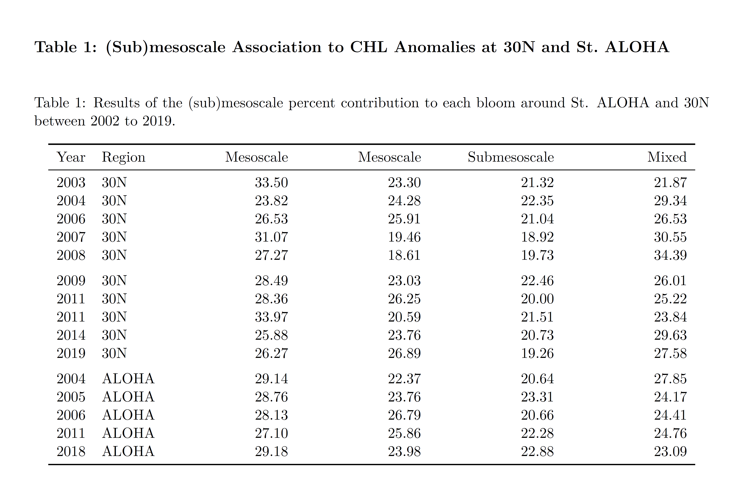

# Figures and captions

Figure 1. Monthly composites of merged GSM CHLsat between 2002-2019 during periods of summer-fall (July-October) blooms in the NPSG. Station ALOHA is shown as a black circle (TBD)

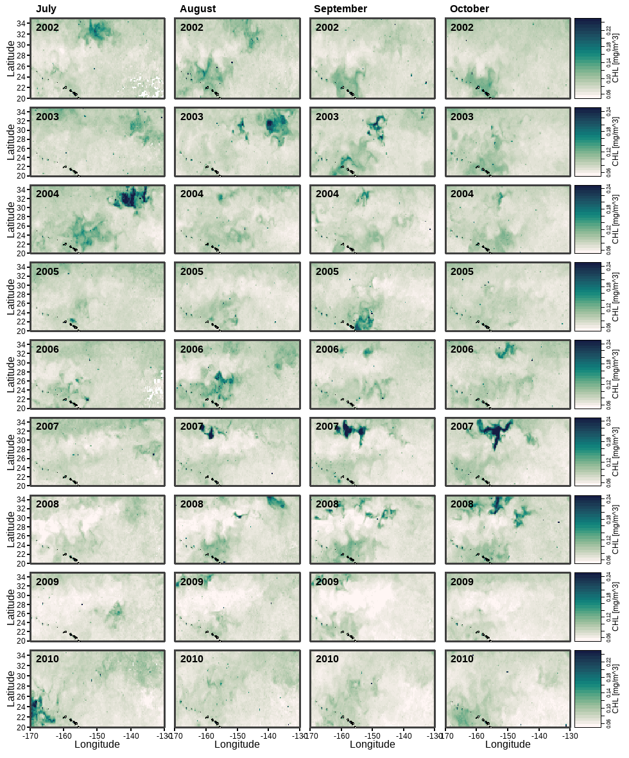

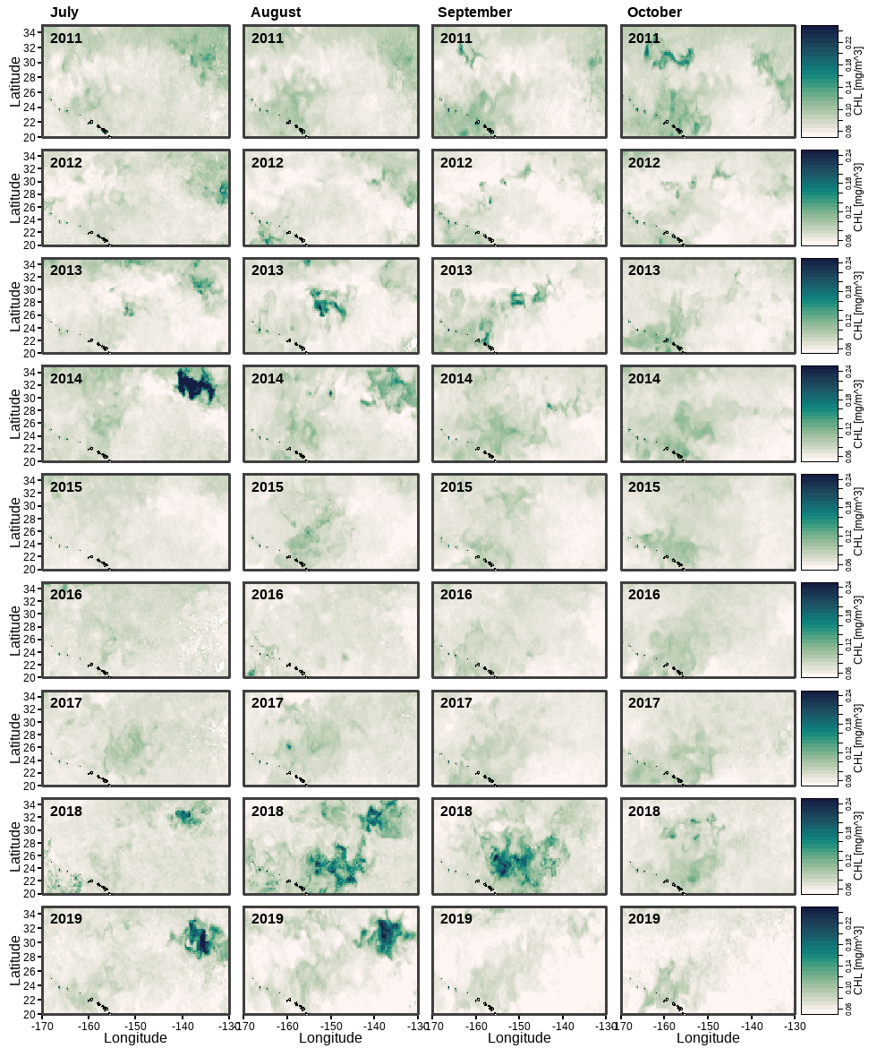

Figure 2. (A) Linear regression of daily CHLsat ± 1 day to HPLC CHL measured by the HOT program in the upper 25 m of the water column rom 2002-2019. (B) Seasonal cycle of CHLsat for the NPSG region around Station ALOHA and the NEPSG region around 30°N. (y-axis needs to be fixed)

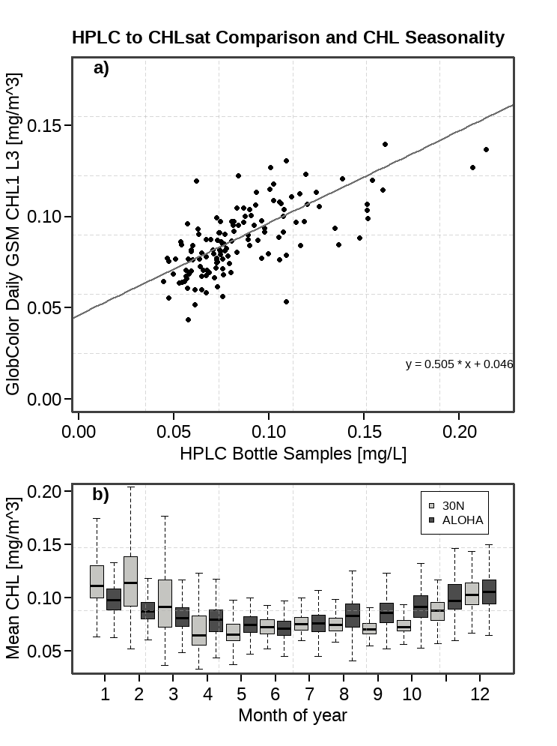

Figure 3. Monthly composites of bloom frequency per grid cell (# CHLanom/ monthly retrievals) between 2002-2019 during periods of summer-fall (July-October) blooms in the NPSG. Station ALOHA is shown as a black circle (TBD)

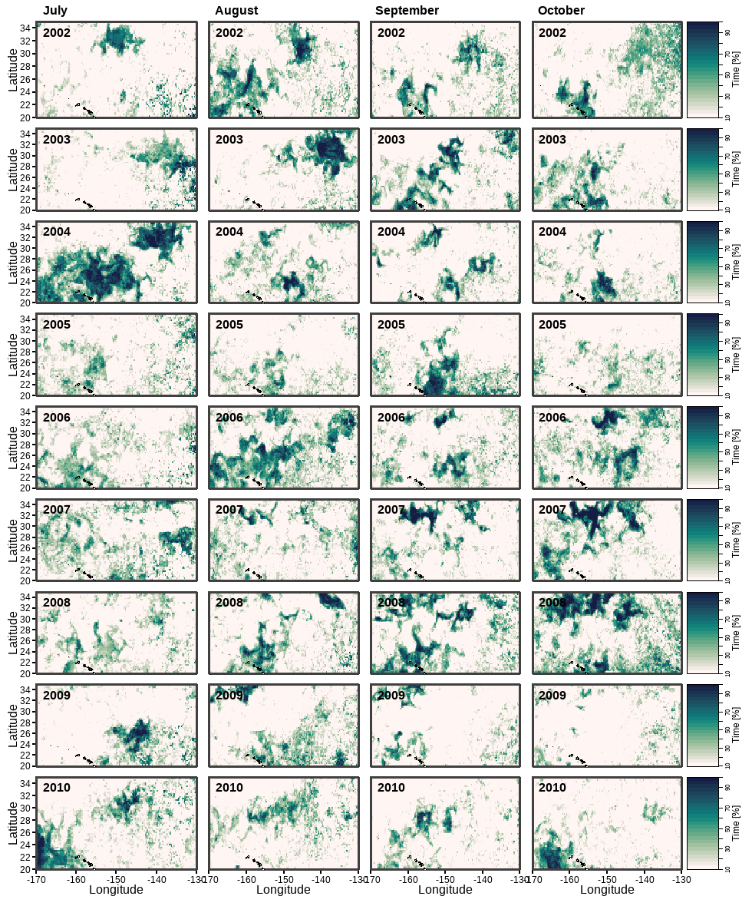

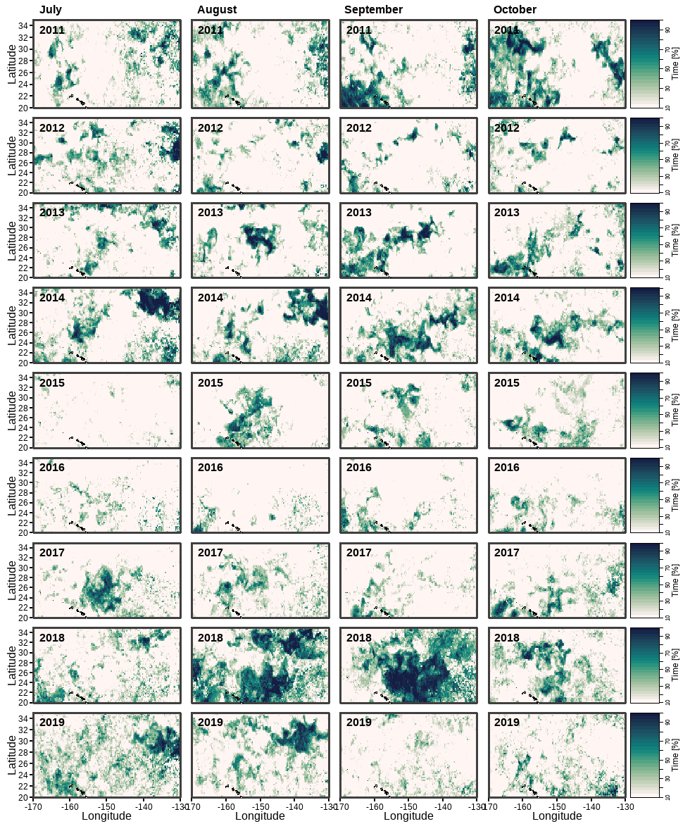

Figure 4. K-means cluster analysis (method = euclidean distance, k = 4, scale = 0-1) applied to the FSLE, and SLA fields at Station ALOHA during the late summer months (July-October) of 2018. The cluster analysis groups each data point into one of four (sub)mesoscale regions: mesoscale positive, mesoscale negative, submesoscale, and mixed regions.

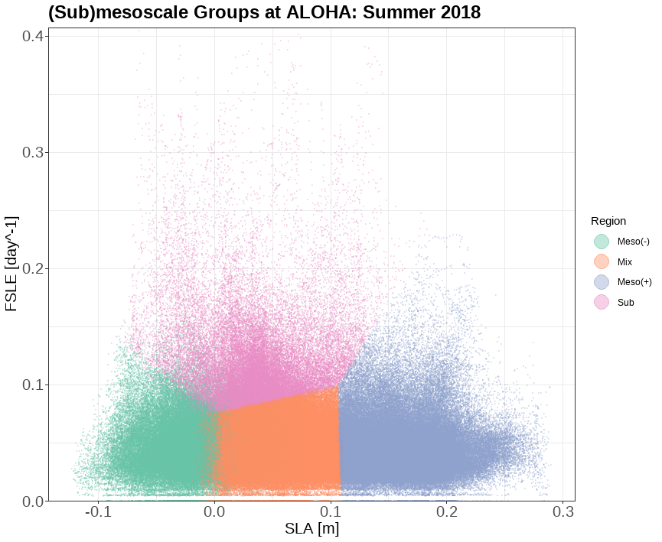

Figure 5. Top figure (a) shows FSLE as blacvk contours overlayed on SLA durring the peak of the 2018 bloom. AVISO outer eddie contours shown as black polygons. The bottom figure (b) shows the output of the k-means cluster algorithm with the four identified regions: Submesoscale (black), mesoscale positive (red), mesoscale negative (blue), and mixted (white).

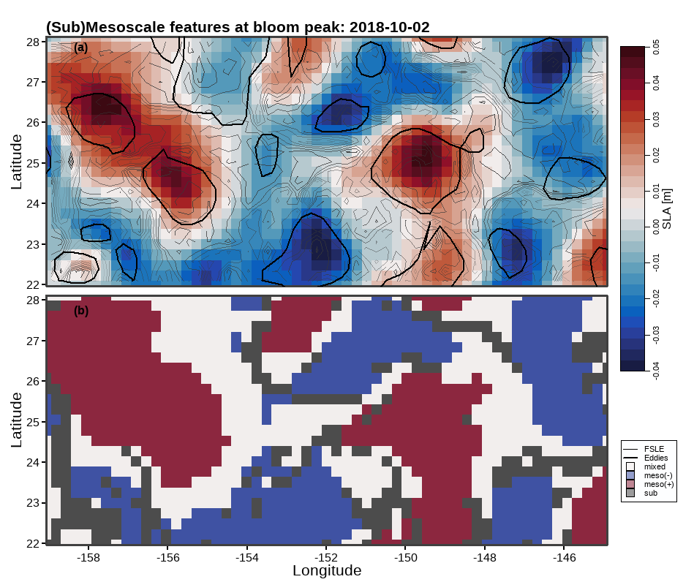

Figure 6. PLACE HOLDER - Spatio-temporal evolution of the 2007 bloom from Lehahn et al. – will generate this same style of figure for 2018

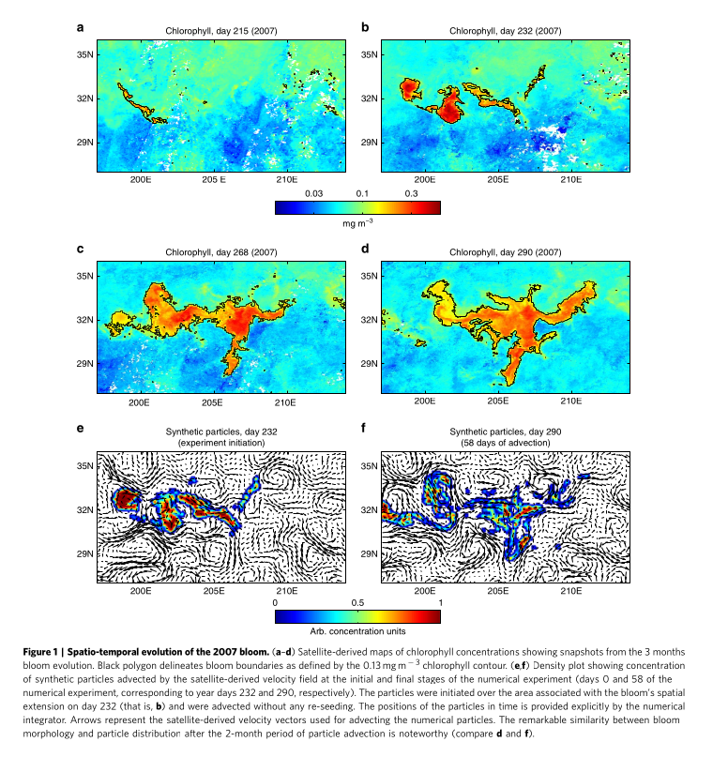

Figure 7. PLACE HOLDER - Satellite-based Lagrangian time series of the 2007 bloom - from Lehahn et al. – will generate this same style of figure for 2018

